Gilcrest Wood (SK301855)
Surveyed 14.6.2013 & 2.7.2013
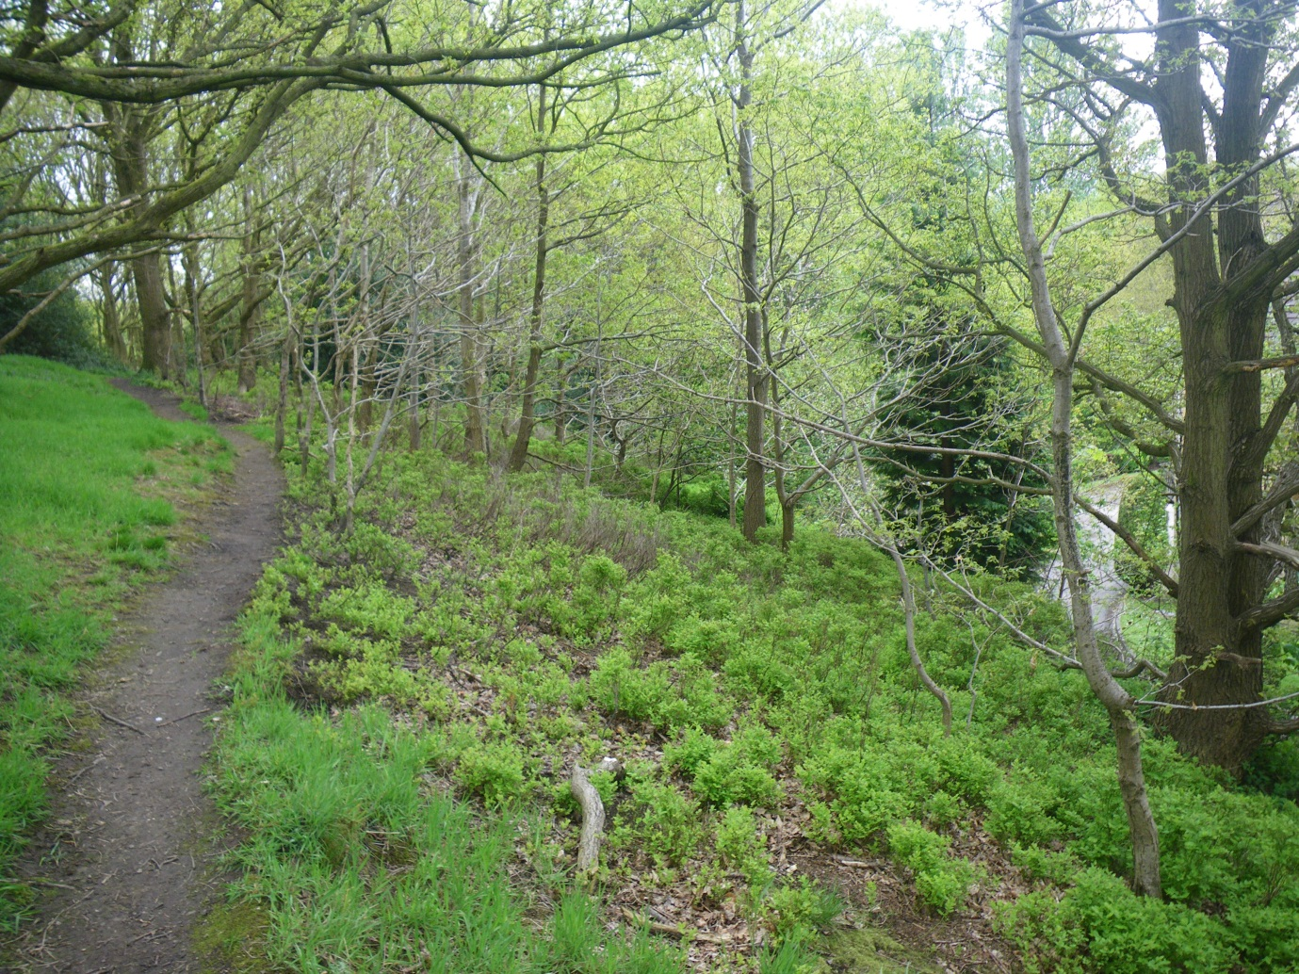

Surveyed by the Friends of Gilcrest Wood
& M. Senkans (SCC Biodiversity Monitoring Officer)

Brief Site Description
Gilcrest Wood is situated in the Fulwood area in the west of Sheffield and is also known as Crimicar Lane Open Space. The site itself sits on a south – east facing bank, sandwiched between Crimicar Lane and Canterbury Crescent. The main habitats include deciduous woodland, scrub woodland and cut amenity grassland. It is owned and managed by Sheffield City Council’s Parks, Woods and Countryside department. For the sake of this survey the site has been divided in to 3 compartments based on typography and habitat type.
Hydrology
Though no water course is present above ground, there are areas of the site which remain wet throughout the year. These occur within the amenity grass area and maybe the result of failed drainage. At the junction of the wooded bank and the amenity grassland there is what appears to be a dried out ditch (mostly hidden by vegetation). A‘seepage’ within the woodland flows down to this ditch.
Access
Access is available from both Crimicar Lane and via a public footpath that links Castlewood Drive and Canterbury Crescent. Desire lines occur throughout the wooded bank.

Compartment 1 / Amenity Grassland
Brief compartment description
This is a narrow strip of amenity grassland cut throughout the summer. It contains a section which remains wet and contains wet grassland species such as lesser spearwort (Ranunculus flammula). This compartment had been unfortunately cut just prior to this survey.
Species list
Herbaceous plants
Creeping buttercup | Ranunculus repens
Meadow buttercup | Ranunculus acris
White clover | Trifolium repens
Daisy | Bellis perennis
Broad – leaved dock | Rumex obtusifolius
Common mouse – ear | Cerastium fontanum
Geranium species | Geranium sp.
Greater plantain | Plantago major
Lesser spearwort | Ranunculus flammula
Germander speedwell | Veronica chamaedrys
Ivy – leaved speedwell | Veronica hederifolia
Thyme – leaved speedwell | Veronica serpyllifolia

Grasses, rushes & sedges
Cock’s – foot | Dactylis glomerata
Common couch | Elymus repens
Crested dog’s – tail | Cynosurus cristatus
Meadow foxtail | Alopecurus pratensis
Rough meadow – grass | Poa trivialis
Yorkshire – fog | Holcus lanatus

Fauna
Speckled wood | Pararge aegeria

Compartment 2 / Ornamental Woodland
Brief compartment description
This comprises of a narrow band of woodland, a mixture of exotic and native species occurs in all field layers.
Species list
Shrubs, trees & woody climbers
Canopy
Beech | Fagus sylvatica
Silver birch | Betula pendula
Norway maple | Acer platanoides
English oak | Quercus robur
Balsam poplar | Populus balsamifera
Sycamore | Acer pseudoplatanus
Willow species | Salix sp.

Shrub layer
Common alder | Alnus glutinosa
Cultivated apple | Malus domestica
Cherry species | Prunus sp.
Cherry laurel | Prunus laurocerasus
Holly | Ilex aquifolium
Leyland cypress | Leyland cypress x Cupressocyparis leylandii
Garden privet | Ligustrum ovalifolium
Spruce species | Picea sp.
Swedish whitebeam | Sorbus intermedia

Ground flora
Shrubs, trees & woody climbers
Common ash | Fraxinus excelsior
Common hawthorn | Crataegus monogyna
Garden honeysuckle | Lonicera sp.
Ivy | Hedera helix

Herbaceous plants
Allium species | Allium sp.
Green alkanet | Pentaglottis sempervirens
Variegated archangel | Lamiastrum galeobdlon ssp argentatum
Wood avens | Geum urbanum
Bindweed species | Calystegia sp.
Spanish bluebell | Hyacinthoides hispanica
Bramble | Rubus fruticosus agg.
Lesser celandine | Ranunculus ficaria
Creeping buttercup | Ranunculus repens
Cleavers | Galium aparine
Columbine species | Aquilegia sp.
Cornflower species | Centaurea sp.
Broad – leaved dock | Rumex obtusifolius
Herb – Robert | Geranium robertianum
Hogweed | Heracleum sphondylium
Iris species | Iris sp.
Stinging nettle | Urtica dioica
Enchanter’s – nightshade | Circaea lutetiana
Cow parsley | Anthriscus sylvestris
Raspberry | Rubus idaeus
Common sorrel | Rumex acetosa
Bush vetch | Vicia sepium

Grasses, rushes & sedges
Cock’s – foot | Dactylis glomerata
Rough meadow – grass | Poa trivialis
Pendulous sedge | Carex pendula

Ferns, horse – tails, Etc
Male fern | Dryopteris filix – mas

Compartment 3 / Gilcrest Wood
Brief compartment description
This comprises the main block of older woodland. The northern half of the compartment is dominated by English oak (Quercus robur), with occasional silver birch (Betula pendula) and holly (Ilex aquifolius) occurring in the shrub layer. Creeping soft – grass (Holcus mollis), scattered wavy hair – grass (Deschampsia flexuosa) and bilberry (Vaccinium myrtillus) are present in the ground layer. Bluebell (Hyacinthoides non – scripta) can also be found. The southern section of the woodland bank is dominated by common hawthorn (Crataegus monogyna) with sycamore (Acer psedoplatanus) and holly. There is also an area of coniferous species, larch (Larix sp.) and pine (Pinus sp.) at the very southern end of this compartment.
Species list
Canopy
Shrubs, trees & woody climbers
Common ash | Fraxinus excelsior
Silver birch | Betula pendula
Horse chestnut | Aesculus hippocastanum
Common hawthorn | Crataegus monogyna
Holly | Ilex aquifolium
European larch | Larix decidua
English oak | Quercus robur
Pine species | Pinus sp.
Poplar species | Populus sp.
Sycamore | Acer pseudoplatanus
Grey willow | Salix cinerea
Willow species | Salix sp.

Shrub layer
Shrubs, trees & woody climbers
Cultivated apple | Malus domestica
Common ash | Fraxinus excelsior
Cherry laurel | Prunus laurocerasus
Elder | Sambucus nigra
Common hawthorn | Crataegus monogyna
Hazel | Corylus avellana
Holly | Ilex aquifolium
Honeysuckle | Lonicera periclymenum
Ivy | Hedera helix
English oak | Quercus robur
Garden privet | Ligustrum ovalifolium
Dog rose | Rosa canina
Field rose | Rosa arvensis
Rowan | Sorbus aucuparia

Ground layer
Shrubs, trees & woody climbers
Holly | Ilex aquifolium
Bilberry | Vaccinum myrtillus
English oak | Quercus robur

Herbaceous plants
Wood avens | Geum urbanum
Heath bedstraw | Galium saxatile
Bluebell | Hyacinthoides non –scripta
Bramble | Rubus fruitcosus agg.
Foxglove | Digitalis purpurea
Japanese knotweed | Reynoutria japonica
Enchanter’s – nightshade | Circaea lutetiana
Garden lady’s – mantle | Alchemilla mollis
Stinging nettle | Urtica dioica
Cow parsley | Anthriscus sylvestris
Bush vetch | Vicia sepium
Rosebay willowherb | Chamerion angustifolium
Strawberry species | Fragaria sp.
Tutsan | Hypericum androsaemum
Woodruff | Galium odoratum

Grasses, sedges & rushes
Wavy hair – grass | Deschampsia flexuosa
Pendulous sedge | Carex pendula
Creeping soft – grass | Holcus mollis

Ferns, horsetails, Etc
Broad buckler | Dryopteris dilatata
Hard fern | Blechnum spicant
Field horsetail | Equisetum arvense

Fungi & slime moulds
Artist’s fungus | Ganoderma sp.
King Alfred’s cakes | Daldinia concentrica

Target Notes
- A wet area within the amenity grassland with the potential to become wet grassland. Management proposal: Reduce mowing, remove cuttings and plug plant native wetland species.
- Another wet area within the amenity grassland, contains lesser spearwort which is not a common species within the Sheffield area. This wet area is adjacent a dry ditch that runs between Gilcrest Wood itself and the amenity grassland. It is hidden by tall ruderal species such as stinging nettle, rosebay willowherb and bramble. Management proposal: mowing should be reduced in areas where this species is present. Reduce to a single cut a year. Arisings (cuttings) need to be removed. As with TN1 plug planting would increase the diversity of this developing habitat.
- This targets a multi – stemmed English oak. Though Gilcrest Wood appears to be a recent feature in the local landscape (maps from the late 19th century show no woodland present), there are several noteworthy trees found within the site, this being one of the best.
- Another mature tree, also a large (single – stemmed) English oak. Management proposal: Below the tree are dense bramble, this stops access to this feature tree. Cutting back the bramble would enable users to appreciate its size (?). A potential seating site?
- The main area of oak dominated woodland. Management proposal: access to the woodland from the amenity grassland needs to be better defined. At present a steep muddy desire line is the main option to access the slope. Steps will be needed if better public access to the wood is to be encouraged. The ranger service could help the friends of group with their construction.
- This is the location of a large colony of bilberry. This species is a typical element of the steep valley side woods found within the Sheffield area and should be retained and encouraged to spread. Management proposal: young oak self – sets are shading out the bilberry, these are small enough to be removed as part of a ranger led workday. Brash should be stacked on site to encourage invertebrates and fungi.
- In the southern scrub dominated arm of the wood there is a large fallen common ash. Though decay has set in, the base to the tree has new growth. Management proposal: Dead wood is a vital part of any healthy woodland eco – system. Not only does it provide a potential habitat for burrowing invertebrates and the birds that prey on them, but it also creates the ideal substrate for a lot of woodland fungi. Leaving dead wood in situ encourages diversity and this fallen giant ticks all the boxes if it is left to decay where it fell. Ring barking unwanted ‘weed tree species’ should be considered as this creates standing dead wood. This is best practiced away from well used paths but is used regularly in Sheffield’s woodlands to encourage species such as woodpeckers and if pollarded, open up the canopy. Brincliffe Edge Wood contains a number of these dead standing pollards.
- This marks the location of an isolated bilberry colony and a clump of hard fern. The latter species tends to be found in the steep thin soiled woods to the south and west of the Sheffield area. Management proposal: as with TN6 overhead shade needs to be reduced if the bilberry is to survive and proliferate. In this case a balance is needed as the hard fern prefers some shade!
- At the base of the wooded bank is what appears to be a ‘wall’ of holly, which on further inspection is actually a large single specimen (veteran?) whose branches have rooted to the ground (layering) creating a curtain of living holly. Management proposal: Clearing away some of the taller vegetation from around this feature tree would further its appreciation. Below this holly is where the ephemeral wet ditch seems to end (TN’s 1 & 2)
- This is where a large patch of Japanese knotweed is located. .Management proposal: The Woodlands Project Officer needs to bring in a licenced contractor to spray this out. This could take 2 0r 3 years to eradicate. As this invasive species is also present above the woodland, the group needs to be vigil and note the location of this species should they find it elsewhere or on the site.
General Management
Compartment 1 / Amenity Grassland
At present this is cut throughout the summer and the arisings left to breakdown in situ. Where the grass is wet, species such lesser spearwort can be seen, suggesting that this part of the site has potential to be managed as wet grassland. This could be done by reducing the grass cut to one single cut carried out early autumn. Due to the small size of the area, this could be cut by hand and the cuttings left elsewhere on site to break down. Plant plugs could be used to increase the diversity of these wet areas.
Leaving a margin of longer grasses along the Gilcrest Wood edge would also encourage diversity. At present a band of tall ruderal species (bramble, stinging nettle, rosebay willow, Etc) separates the woodland from the amenity grassland. Leaving a strip of taller grasses between would be beneficial for invertebrates and could be further enhanced by planting wildflower plugs. This would be managed by a single early autumn cut. The arisings should be removed and composted on site, this could be done as part of a workday with the ranger service.

Compartment 2 / Ornamental Woodland
This strip of native and exotic species trees is shady and lacking in healthy structure. Selected thinning would open up the canopy and allow light to reach the ground layer. Species such as Norway maple, sycamore and cherry laurel could be targeted. Discussion with John Gilpin / Woodlands Project Officer (SCC) should be sought.
Compartment 3 / Gilcrest Wood
Evidence that protected mammal species use the wood was found during these site visits, To avoid infringing on the safety of this species careful consideration will be needed as to the route of any path constructed through the woodland. The presence and location of this species should be kept quiet so as to lessen the chance of persecution. Natural England provide downloadable information regarding working within close proximity of these protected animals.
As with compartment 2, opening up the canopy, would reduce over shading and benefit areas where the ground flora struggles. Ring barking to create standing dead wood should be considered. Any cut timber should be left in situ to breakdown (habitat piles could be constructed as part of a workday)
The addition of bat and bird boxes to the site goes without question. These can be purchased either in kits or fully built or can be easily made from scrap timber (another activity for a potential workday / event?). There are numerous websites dedicated to simple nest and bat box construction, namely the RSPB and the Bat Conservation Trust.
Japanese knotweed occurs in this compartment. This needs to be sprayed out by licensed contractors. The woodlands Project Officer is the point of contact for this invasive species.

